Assignment # _3__ Name _Diogo Delgado

Program 1 :__FinancialAssistance.py_________( give filename)

**Screenshot (Sample Run):**  GIVE IMAGE screen shot of the program running

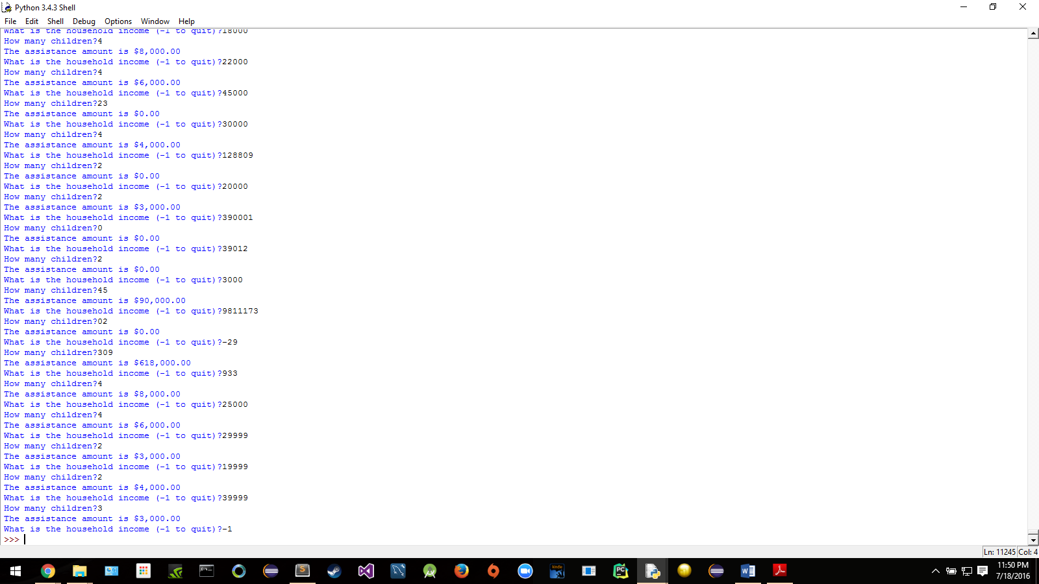

Program 2 :______Query.py___________( give filename)

**Screenshot (Sample Run):**  GIVE IMAGE screen shot of the program running

